**Daily Scrum or Standup Meeting**

Team name: _____Group 2____________________

Scrum Master: ____Emily___________________

Date:_______10/8________________________

| **Team Member** | **What did you do since the last scrum?** | **What do you plan to do before the next scrum?** | **What obstacles do you have?** |
| --- | --- | --- | --- |
| Emily Thomas | Set up model / view for editing inventory. A user can now select how much they want to add, and it will increment the inventory quantity. | Calculate how much manager owes after incrementing quantity | I think I need a reduceManagerBalance function to do this |
| Maris Hurst | Copy user auth basics from prototype | Add the functionality of different users and change “landing page” based on user log in/permission | Learn how to differentiate between user types and permissions |
| Karl Poulsosn | Finished Login Page styling and general page layout | Finish User view template and styling | How to position elements so they look pretty |
| Andre Nguyen | Finished the add drink and remove drink method | Implement the change/edit drink methods | How to merge the menu setup with Emily’s changes |
|  |  |  |  |

# Burndown

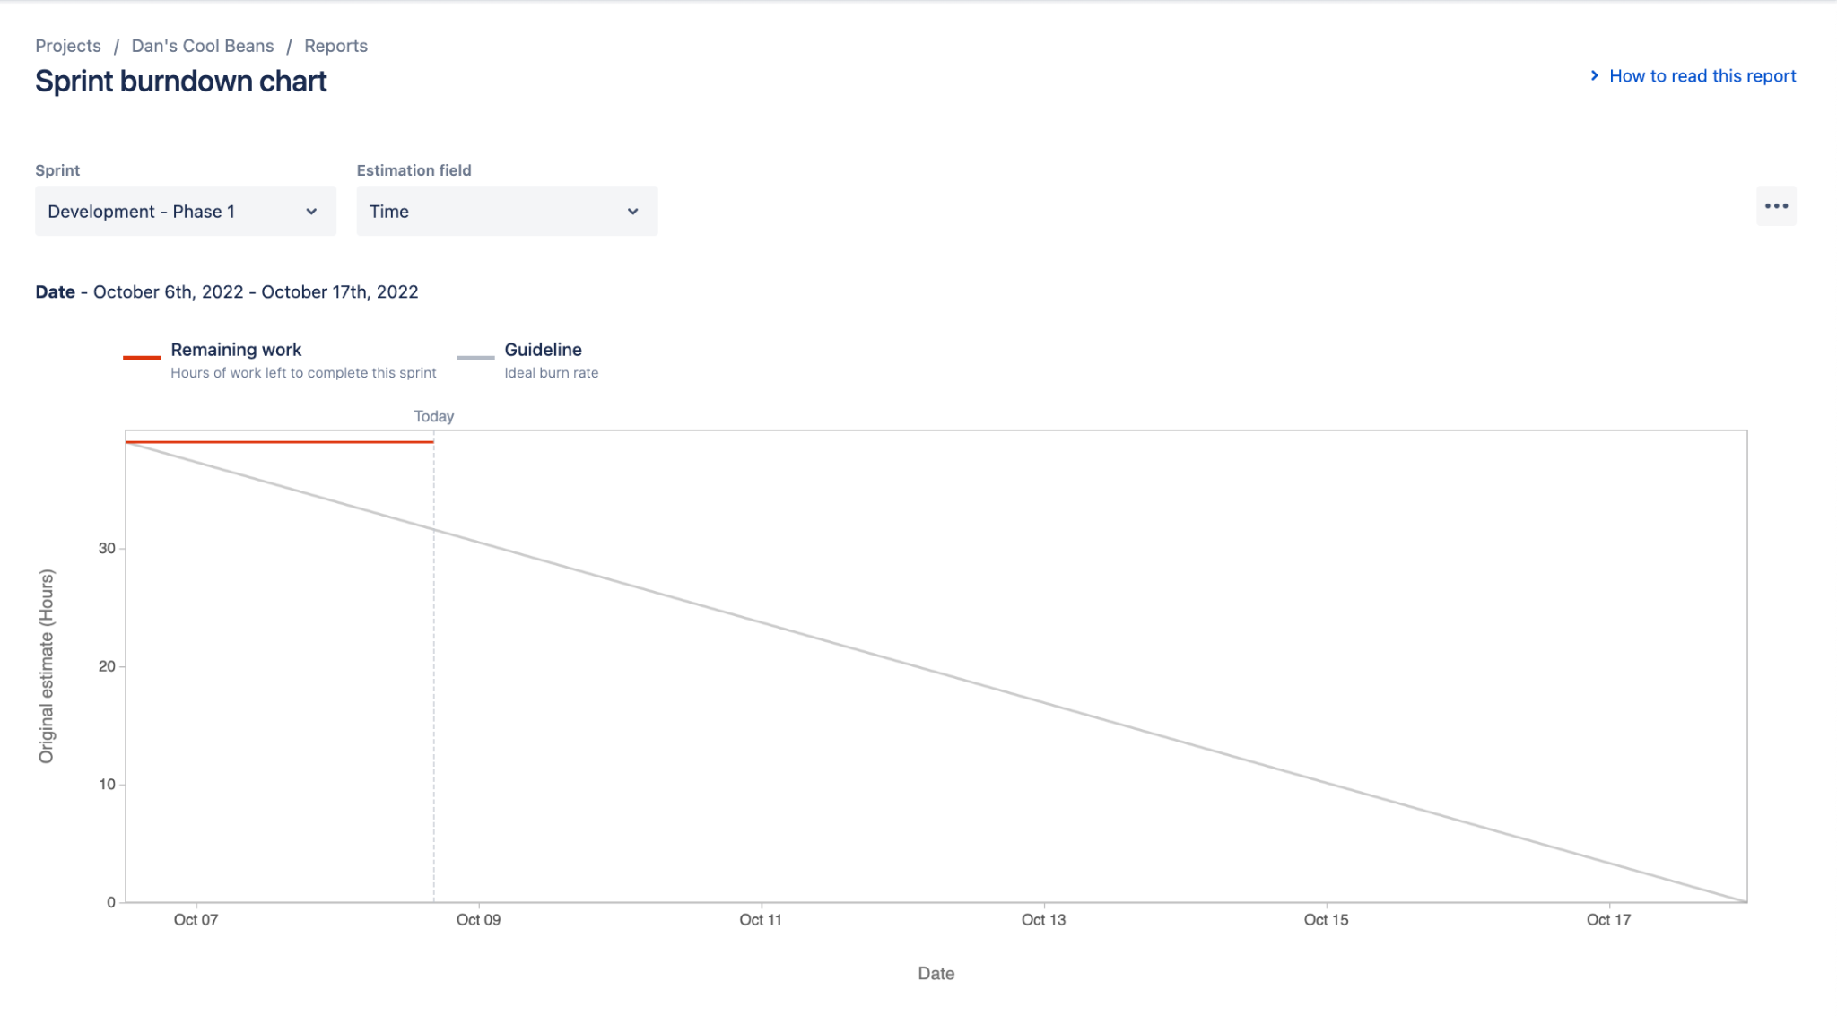

# Screenshot of you project board

